RESOLUTION NO.__________

RE: CERTIFICATE OF APPROPRIATENESS UNDER THE
PROVISIONS OF THE ACT OF THE PENNSYLVANIA
LEGISLATURE 1961, JUNE 13, P.L. 282 (53
SECTION 8004) AND BETHLEHEM ORDINANCE NO.
3952 AS AMENDED.

WHEREAS, it is proposed to change the projecting sign at 19 E Third Street.

NOW, THEREFORE, BE IT RESOLVED by the Council of the City of Bethlehem that a Certificate of Appropriateness is hereby granted for the work.

Sponsored by: (s)

(s)

ADOPTED BY COUNCIL THIS DAY OF

(s)
President of Council

ATTEST:

(s)
City Clerk

HISTORIC CONSERVATION COMMISSION

CASE # 568– It is proposed to change the projecting sign at 19 E Third Street
OWNER/APPLICANT: Charles Buck / Bill Morris

The Commission upon motion by Mr. Roeder seconded by Mr. Evans adopted the proposal that City Council issue a Certificate of Appropriateness for the proposed work described herein:
- The proposal to change the projecting sign at 19 E Third Street was presented by Bill Morris.
- The new sign will be 15 ¼” x 29 ½” oriented on a 45 degree angle.
- The sign will have a blue and red domino and no writing.
- The internal illumination will not be bright.
- The proposed sign has internal LED illumination and is being granted only because of the following reasons:
  - The sign is very small in size (slightly over 3 sq. ft. in size)
  - The sign is a custom designed sign and not a standard box sign
  - The sign is unique, oriented at a 45 degree angle, and has a single post-like bracket
  - The thickness of the sign is only 2”.
- The sign must be modified if the LED’s in the sign are too bright.
- The proposed motion was unanimously approved.

CU: cu
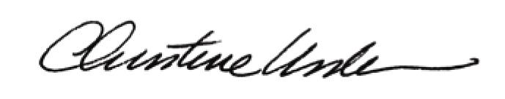

By:

Date of Meeting: October 19, 2015 Title: Historic Officer

